**Dynamic volume provisioning:**

* Here we create storage classes. And we can set the default storage class so that it will be taken automatically if we don’t mention the storage class.

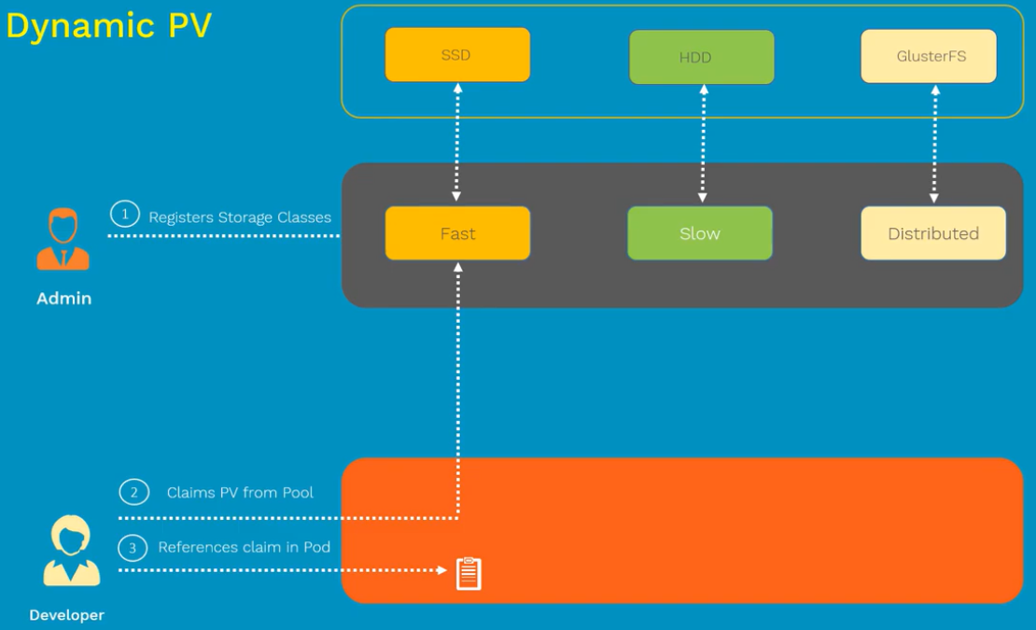

* Here, we no need to create PVs every time.

**Manifest file:**

* These objects can not be updated once created.
* We need to give IAM permissions to create volume

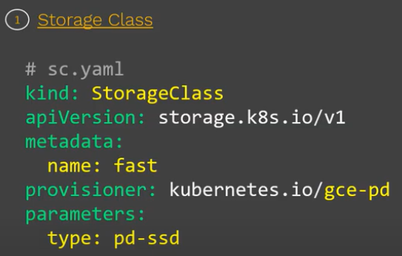

* Provisioner is the plugin we give there.
* If we don’t mention anything in “type”. It will create default pd standard disk.

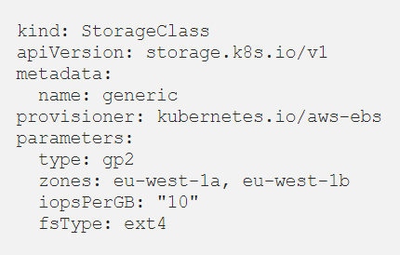

**Create & display:**

* If we want fast speed SSD storage drives. Then we specifically mention that in yaml file

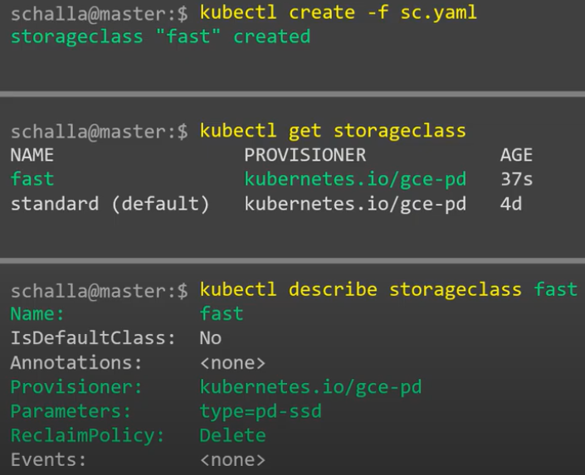

* As above, default storage class is already there. If user won’t mention **“fast”** storage class specifically to pick from the class which we have created in above example, it will pick the default one automatically.

**PVC manifest file:**

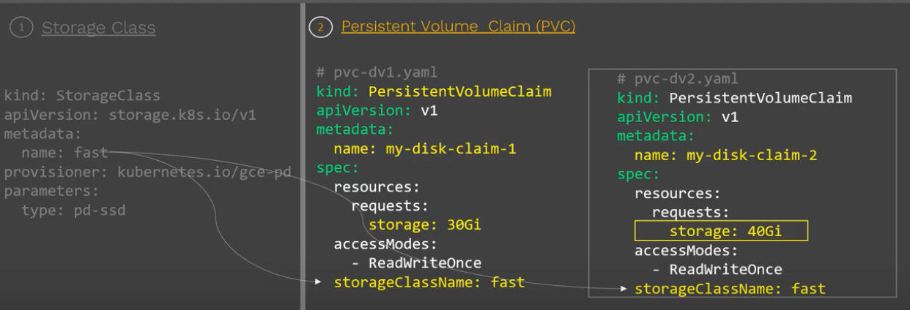

**Create & display:**

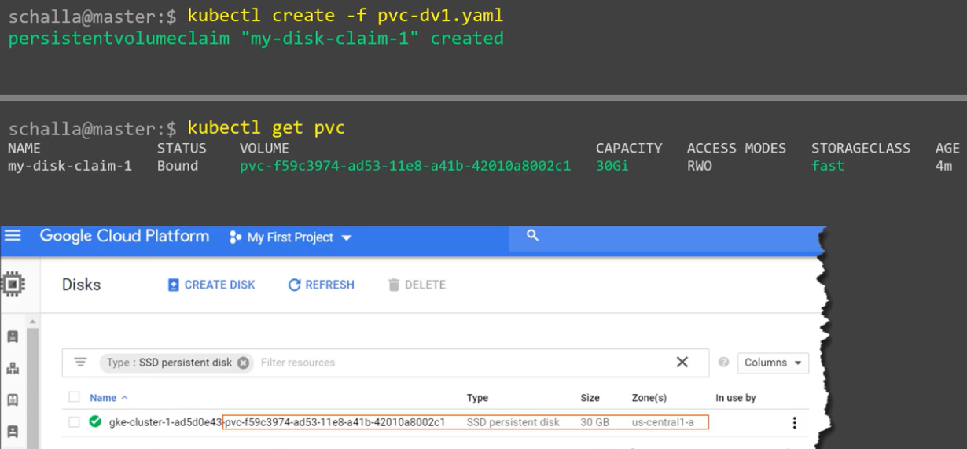

* As we can see, it created the disk in google cloud above.

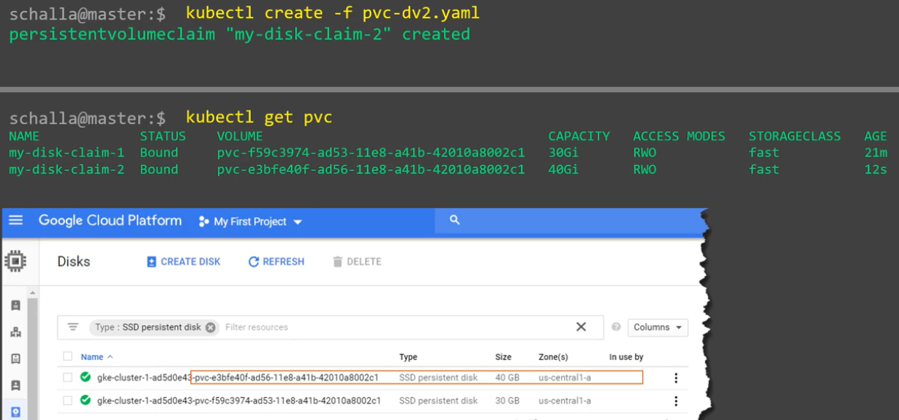

**POD manifest file:**

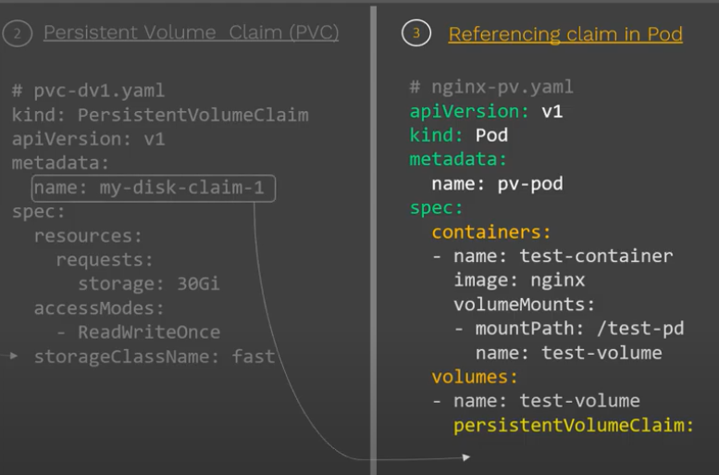

**Create & display:**

